DRAFT
UN-convened Net-Zero Asset Owner Alliance
Tender to developers - Alliance Digital Map of Climate Solution Investments
Tender to

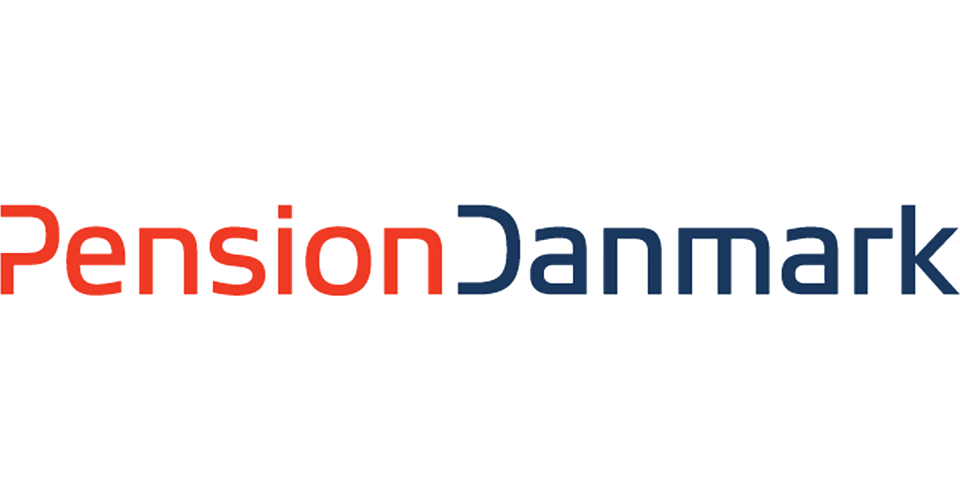
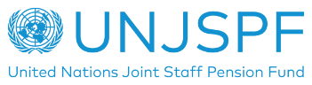
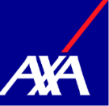
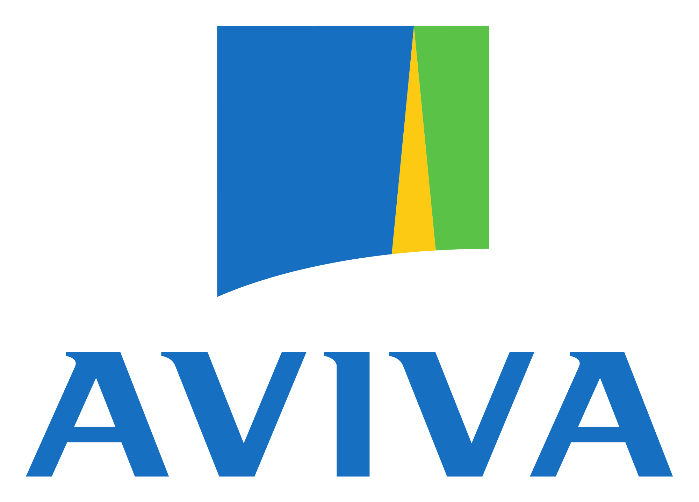
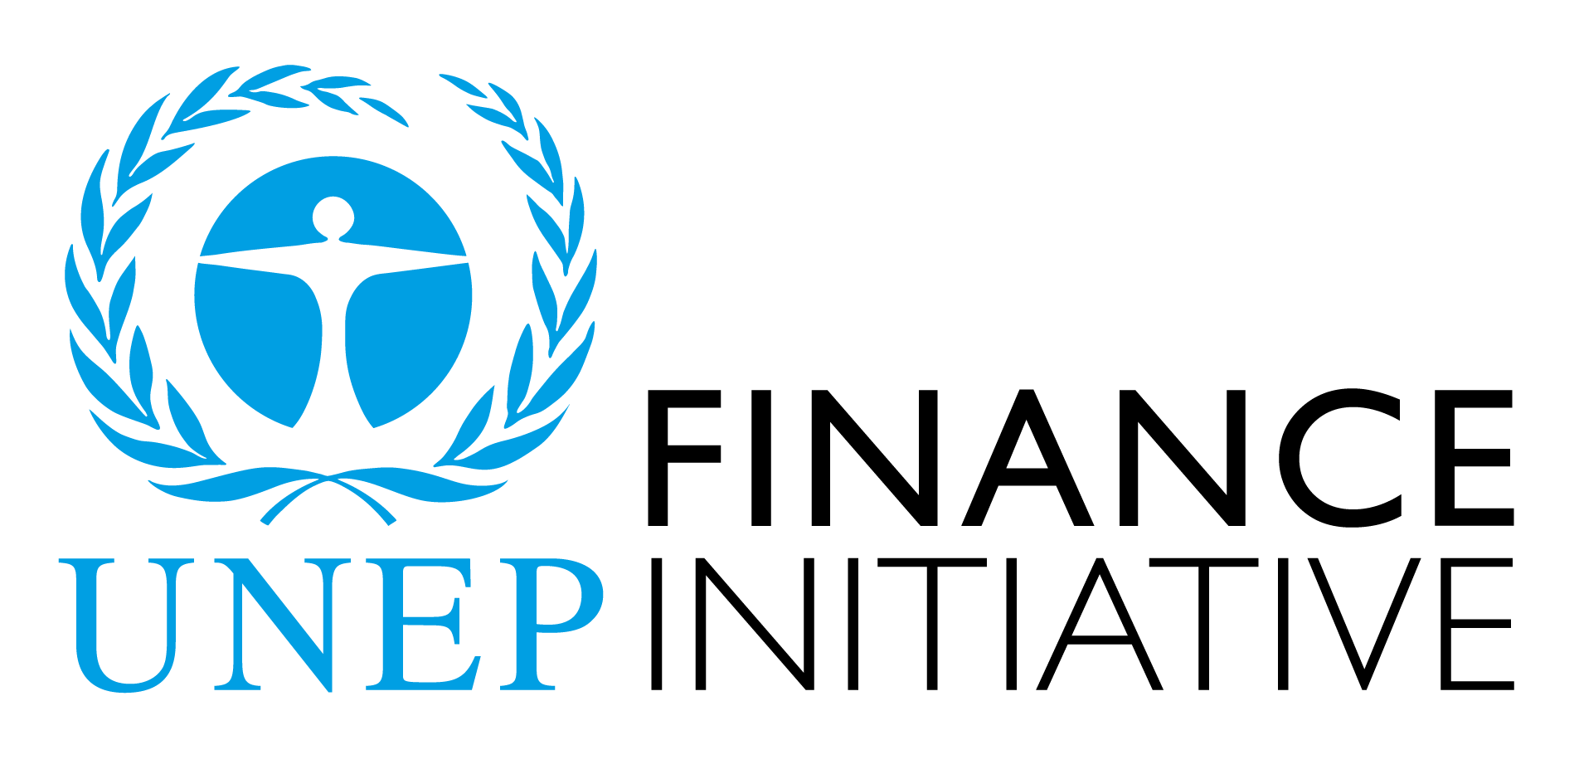

https://www.unepfi.org/net-zero-alliance/alliance-members/

Convened by:

Alliance Climate Solutions Investments Digital Map – Tender to information & data provider platforms

UN-convened Asset Owner Alliance

The UN-convened Net Zero Asset Owner Alliance (the Alliance) is a PRI and UNEP FI supported initiative. The members of the Alliance have committed to i) transition their investment portfolios to net-zero GHG emissions by 2050 consistent with a maximum temperature rise of 1.5°C above pre-industrial levels; ii) establish intermediate targets every five years; and iii) regularly report thier progress. The first set of intermediate targets for the year 2025 have already been published.

A core focus area of the Alliance is “Financing Transition”. To address this, the Alliance has a dedicated working group focused on identifying priority investment segments to scale up climate solution investments and “technologies for tomorrow” in OECD and non-OECD markets. Through this, the Alliance aims to develop and publish a digital map providing relevant information for investors on investable low carbon /climate solutions per sector (e.g., new technologies or nature-based solutions etc.). The map should serve as a guide and catalyst for investors seeking information on low-carbon solutions from an investment perspective, building on available information, and helping to navigate through opportunities.

To commence this work, the members of the Alliance wish to engage with existing platforms, information & data providers to support this work and help build this knowledge platform with the objective to provide relevant information to investors.

Request Details

- In the context of its Alliance targets the members of the Alliance want to provide transparency on climate solutions.
- Due to a perceived gap in the market regarding climate solutions information paired with investor relevant information, the investors require a digital map / platform as a go-to place to obtain relevant information and to be able to start investing into a broader set of climate solutions.
- The Alliance members are looking for partners that would support the Alliance in this endeavor.
- The Alliance members will work with the selected information providers that meet the below criteria and support our effort. The information on the digital map / platform should be open source / accessible to other non-Alliance investors free of charge.

Platform Requirements

Core Criteria:
- The digital map/platform should provide information from a number of sources, including but not limited to:
  - Technical screening criteria from the EU Taxonomy for determining the conditions under which an economic activity qualifies as contributing substantially to climate change mitigation /adaptation and for determining whether that economic activity causes no significant harm to any of the other environmental objectives.
  - Climate Solution information by sector from Project Drawdown
  - World Energy Outlook 2020 information referring to various climate solutions.
  - Relevant data from the One Earth Climate Model (this data can be provided as a feed into the system via the AOA)
  - Economic KPIs (expected returns, investment horizon etc.) linked to climate solutions per region
  - Market size of investable climate solutions
  - Asset Class (split)
  - Region & Currency
  - GHG emission intensity (scope 1+ 2 if available also scope 3)
  - ESG standards / do no significant harm on non-climate ESG related aspects.

Further Criteria:
- Percentage of solution contribution: How much of the investment in the fund contributes to specific climate solutions (e.g., 9% renewable energy, 15% net-zero buildings, etc.)
- Available financial information : e.g. indicative IRR, currency, etc.
- Available fund information:
  - first loss available or other de-risking mechanisms? (e.g. guarantees, junior equity, junior debt)
  - Reporting KPIs (e.g. avoided emissions, carbon removal, climate solution technologies, …)
  - net-zero target in place?
  - Compliant with XX regulatory framework
  - Climate solutions invested with regards to the classification system (pls provide examples)
  - Key terms: financial KPIs only if shareable on an open-source platform
    - track record
    - return
    - vintage
    - team (size, key persons, offices, …)
    - target size
    - transaction (sectors, type, size, …)
    - term, investment period
    - fees

Please find below an example how this platform could look– final set-up and infrastructure will be discussed with the applicants:

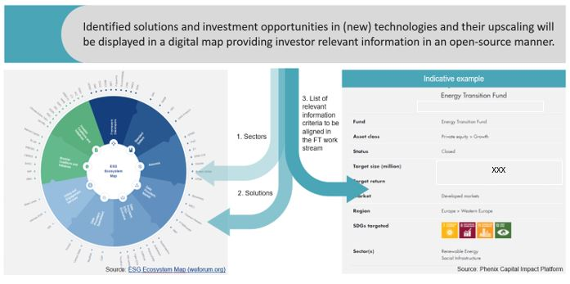

Data Provider Application Form

We kindly ask you to provide your submission with the application form available via an online form here - https://forms.office.com/Pages/ResponsePage.aspx?id=DVfC-4-p8UGorRKxMb2T6HGFQA6eW6NPrFHLvDEDJPJUOFhYWTUwOFNPVjlLNlFRUVo5RDNWM01QRS4u

If you cannot access this link, please use the form below and return to Ashley Minshull ashley.minshull@unpri.org

Provider Name:

Platform Information

Platform Coverage: (tick all that apply)

- Technical screening criteria from the EU ☐
- Project Drawdown ☐
- World Energy Outlook 2020 ☐
- One Earth Climate Model ☐

- Other, please specify -

Platform Data: (tick all that apply)

- Economic KPIs of climate sol. (e.g. cost related to climate solution & region) ☐
- Market size of investable climate solution ☐
- Asset class (split) ☐
- Region & Currency ☐
- GHG emission intensity (scope 1+ 2 if available also scope 3) ☐
- follow high ESG standards / do no significant harm on non-climate ESG related aspects ☐

- Other, please specify -

Available Financial & Fund Information
Percentage Climate Solutions: (How much of the investment in the fund contributes to specific climate solutions?)

Financial Information:

Fund Information:
First loss available or other de-risking mechanisms? (e.g. guarantees, junior equity, junior debt)
De-risking mechanisms:
Reporting KPIs (e.g. avoided emissions, carbon removal)climate solution technologies, …)

Reporting KPIs:

Net-Zero Target:
Net-zero target in place?

Compliance:
Compliant with XX regulatory framework

Classification Systems:
Climate solutions invested with regards to the classification system (pls provide examples)

Key Terms:
    - track record ☐
    - return ☐
    - vintage ☐
    - team (size, key persons, offices, …) ☐
    - target size ☐
    - transaction (sectors, type, size, …) ☐
    - term, investment period ☐
    - fees ☐

    - Other

Further information / ideas / input / feedback:

Contact Information

Email Address:

Website URL:

