Principles for Responsible Banking
Key Steps for implementing the Principles

The Principles for Responsible Banking require your bank to take three key steps designed to ensure the effective implemetation of the Principles, and to enable your bank to continuously improve and manage its impact on and contribution to society and environment.
These key steps — 1) impact analysis, 2) target setting&implementation and 3) accountability – are summarized in this document.

PRB implementation journey
Your bank may take up to 4 years to initially implement the Principles for Responsible Banking by applying 3 Key Steps and fulfill the requirements for each of the Key Steps as detailed further below and in more depth in the RSAT. These requirements for impact analysis and target setting respectively constitute a significant stepping up of current practice in most banks. Noting in addition that the PRB are a global framework and thus bring together banks with very different starting points and operating contexts, your bank should have completed a first impact analysis, set targets in two different areas of most singificant impact and reported at least three times in the first four years. Working towards reaching the targets set will in most cases require longer time horizons.
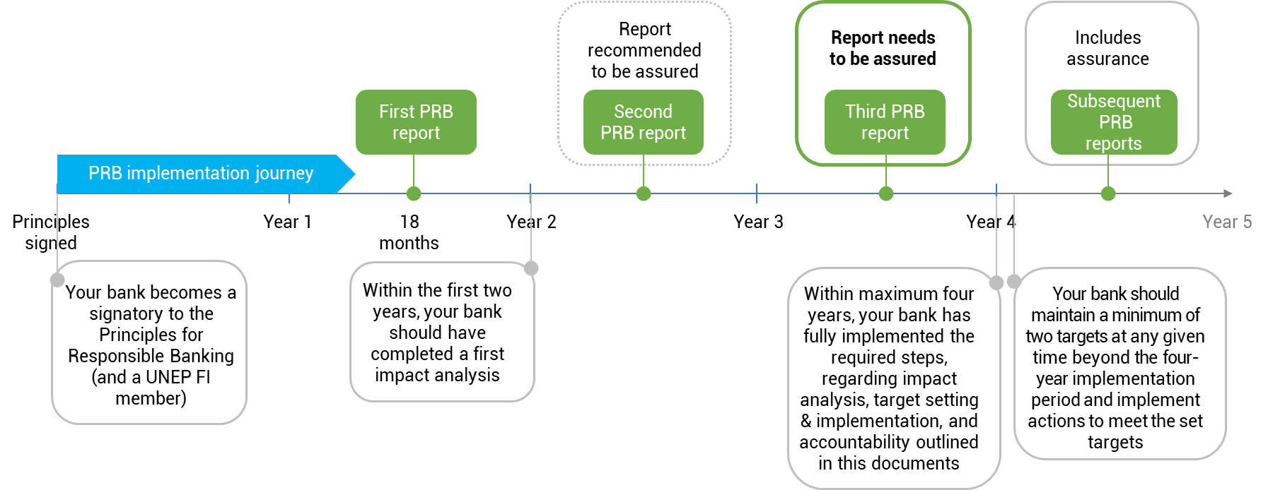
Figure 1: PRB implementation journey
Your bank can rely on substantial support in implementing the required steps. By becoming a signatory to the Principles for Responsible Banking and with that a UNEP FI member, your bank joins the global banking community focused on sustainable finance, sharing best-practice and working together on practical guidance and pioneering tools of benefit to the entire industry. You will have access to a support framework, which includes individual reviews, capacity building, training, peer-to-peer exchange, access to scientific and academic experts, multi-stakeholder engagement, and workshops to tackle challenging issues as a collective effort.
The UN Environment Programme Finance Initiative (UNEP FI) Secretariat and the Banking Board will engage with your bank and provide support and guidance if your bank is not in line with these requirements. Sustained and unexplained failure to address shortcomings can result in your bank no longer being listed as a signatory.
Putting governance structures in place is a key enabler and facilitator of achieving the 3 Steps described below. Embedding governance and creating structures where aspects of the PRB are governed by appropriate bodies or committees enables your bank to create the internal changes that are a prerequisite to underpin the work banks have to do.

Step 1 Impact Analysis
Green summary text box:
Analyse where your bank has significant positive and negative impacts on society and the environment. Then identify where your bank can realize the greatest positive impacts and reduce significant negative impacts.
Conduct an impact analysis to identify your bank’s most significant (potential) positive and negative impacts on the societies and environment where it operates. Your impact analysis should cover your core business areas. This is defined by your main customer segments served, types of products and services provided, the main sectors and types of activities, across the main geographies in which your bank has operations or provides products and services. Your bank should engage relevant stakeholders, including civil society, to inform aspects of the analysis.
Elements you should take into account for your impact analysis include
- Scope, i.e. the bank’s core business areas, products/services across the main geographies that the bank operates in
- Portfolio composition, i.e. the proportional composition of your bank’s portfolio by sectors & industries for business, corporate and investment banking portfolios, and/or by products & services and by types of customers for consumer and retail banking portfolios
- Context, i.e. the main challenges and priorities related to sustainable development in the main countries/regions in which your bank and/or yor clients operate
- Performance measurement, i.e. the bank’s current performance level of quantitative and qualitative indicators of the social and environmental impacts resulting from the bank’s activities and provision of products and services.

Guidance materials on impact analysis as well as the Reporting and Self-Assessment Template provide further details about the requirements for undertaking your bank’s impact analysis. The Portfolio Impact Analysis Tool for Banks can guide your bank through a quantitative impact anal ysis of its consumer, business, corporate and investment banking portfolios, however over time it is expected that impact analysis is deeply contextualized for each banks priority impact areas.

Step 2 Target Setting & Implementation
Green summary text box:
Set SMART targets that address the significant impacts your bank has identified, and work towards achieving them.

Set ambitious targets:
Set and publish a minimum of two targets that address at least two of your bank’s most significant positive and negative impacts. Your targets should clearly drive alignment with and greater contribution to appropriate Sustaina ble Development Goals, the goals of the Paris Agreement, and other relevant international, national or regional frameworks. Your targets need to be Specific, Measurable (quantitative or qualitative), Achievable, Relevant and Time-bound (SMART) and should be based on the following elements of target setting:
- Alignment: Identification of relevant international, regional or national frameworks to align with
- Baseline: Assess the current level of alignment and determine a baseline
- SMART targets: set targets for your first and your second area of most significant impact, incl. KPIs used to monitor progress towards reaching the target
- Action plan: Develop an action plan incl. milestones to meet the set targets
Negative impacts which may result from the implementation of the targets set should be identified, and, as far as feasible, actions should be taken to avoid, mitigate or compensate them.
Guidance documents for several impact areas can support you in your target setting process.
Your bank can revise its targets and establish additional targets at its own pace. However, your bank should establish a minimum of two targets during, and maintain a minimum of two targets at any given time beyond the four-year implementation period.

Implement the targets set:
Set milestones, and define and implement actions to meet the set targets. Establish the means to measure and monitor progress. Put in place a governance and oversight structure responsible for monitoring target implementation and, if required, remedial action.

Step 3 Accountability
Green summary text box:
In your bank’s existing reporting, describe how your bank is implementing the Principles for Responsible Banking. Provide an assured assessment of the progress that your bank is making.
Show your progress on implementing the Principles and be transparent about your impacts and contributions:
Report on how you are implementing the Principles for Responsible Banking, the targets you have set for your bank and the progress you have made. Be transparent about your significant impacts—positive and negative—and your contribution to society. Once you have set targets, show that you have implemented your planned actions and are making progress towards achieving your targets. Establish a governance structure to oversee implementation of the Key Steps. You do not need to produce an additional report for the Principles for Responsible Banking. Include the required information in your existing public reporting (e.g. annual report, sustainability report etc.).

Assess if you are meeting the requirements and obtain assurance:
In the Reporting and Self-Assessment Template, you will provide a self-assessment of your progress in implementing the required steps regarding impact analysis, target setting & implementation and accountability. An assurer needs to provide limited assurance of your self-assessment on implementing the 3 Key Steps. Where third-party assurance is not feasible, an independent review may be conducted.
Based on banks’ aggregated individual reporting, every two years, signatories will take stock and through UNEP FI publish their collective progress.

Governance of the Principles for Responsible Banking and outlined requirements
Every two years, as part of the UNEP FI Annual General Meeting, signatories of the Principles for Responsible Banking will discuss any recommendations for revisions and updates to the framework, or, if necessary, to the Principles themselves. Any changes to the Principles and framework must be voted on by the signatories following a proposal from the UNEP FI Banking Board. The Banking Board will consult with relevant stakeholders, including members and civil society, regarding any such revisions.

