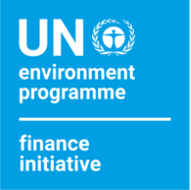
Communications Pack
500 UNEP FI Members

We are pleased to announce that the UNEP Finance Initiative (UNEP FI) reached 500 members. As a member of the initiative, we invite you to take part in UNEP FI’s 500 members' communications campaign.

This pack includes suggested copy and a visual for social media as well as for web and/or email communications. If you have any question, please contact us.

Social media card (right-click to save as picture)

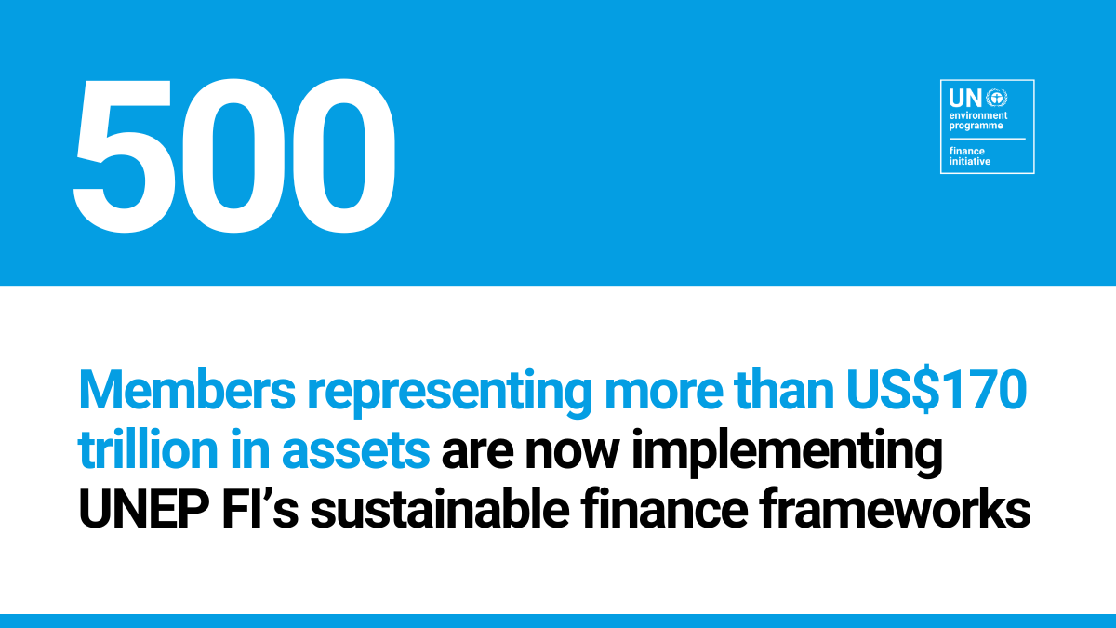

Suggested social media copy
LinkedIn/Facebook
We are proud to be part of the largest United Nations-convened network of banks, insurers and investors working to deliver positive impacts through #SustainableFinance!
The @United Nations Environment Programme Finance Initiative (UNEP FI) that [company name] joined in [year] catalyses action across the finance system to align economies with sustainable development. Join us now: unepfi.org

Exciting news for #SustainableFinance – The @United Nations Environment Programme Finance Initiative (UNEP FI) reached 500 members! [Company name] is proud to be part of this United Nations-convened network of global financial institutions since [year]. Discover how we are implementing our sustainability commitments to deliver positive impacts: unepfi.org

Twitter
We are proud to be part of the largest United Nations-convened network of banks, insurers and investors working to deliver positive impacts through #SustainableFinance! Join us now: unepfi.org @UNEP_FI

Exciting news for #SustainableFinance – @UNEP_FI reached 500 members! [Company name] is proud to be part of this United Nations-convened network of global financial institutions. Find out how we are collectively delivering positive impacts through finance: unepfi.org

Suggested email/web copy
500 global banks and insurers representing more than US$170 trillion in assets
now form part of the United Nations Environment Programme Finance Initiative (UNEP FI), the largest network bringing together the United Nations and the finance sector. Founded in 1992, UNEP FI catalyses action across the financial system to align economies with sustainable development. It has established some of the most important sustainable finance frameworks with the incubation of the Principles for Responsible Investment, and the development and implementation of the Principles for Responsible Banking, the Principles for Responsible Insurance as well as the UN-convened net-zero alliances.
[Company name] is proud to have been a member of UNEP FI since [year]. Discover how we are implementing our sustainability commitment to deliver positive impact: [link to your sustainability page]

