Thank you for your interest in becoming a UNEP FI member.
By becoming a member, your organization commits to:
- applying the Principles for Responsible Banking (PRB). Your bank has the option to additionally join PRB’s climate flagship initiative, the Net-Zero Banking Alliance (NZBA).
- participating in the Annual General Meeting (AGM), an assembly of all Members with the ultimate decision-making authority for UNEP FI. Members are committed to attending the online AGM every year and participating in the annual online voting processes.
- paying an annual membership fee. The fee level is determined by the level of your organization’s total asset size. The fees for 2024 and 2025 are shown in Appendix 1.
To become a UNEP FI member, your organization will need to send:
- this Membership Application Form completed in all its parts and signed by the Chief Sustainability Officer, Head of Sustainability or similar level. Appendix 1 and 2 include information on the UNEP FI Membership Fee Structure and definitions.
- the Commitment Statement for the PRB or the Commitment Statement for the PRB including NZBA, if signing both initiatives simultaneously. The commitment statement has to be signed by the CEO.
- your certificate of incorporation or a document showing the nature of your banking business (in English) – i.e. your banking license.
- your logo.
to the following addresses:
- Banking Team – Membership: application@unepfi.org
- Membership and Regional Co-ordination: Maria Sosa Taborda at maria.sosataborda@un.org

Upon receipt of the requested documents, the UNEP FI Secretariat will review your application, including a risk assessment, and arrange a call to discuss your membership.
We will then confirm the outcome of your membership application: if successful, you will receive an official letter confirming your status as a member and an onboarding package including:
      - tools to assist you for your public announcement: banks are required to publicly announce with a press release and a quote from the CEO that it has become a PRB Signatory and UNEP FI member (Become a Signatory – UN Environment Programme–Finance Initiative);
      - UNEP FI’s Yearly Work Programme as well as the Annual Overview for the Principles for Responsible Banking and the Members’ Handbook;
      - details of the Working Groups that you may wish to join. Working Groups provide opportunities for exchanging and co-developing materials with your peers, the UNEP FI Secretariat and a broader set of experts;
      - the login details to the members area of the UNEP FI website with additional documents and information to support implementation;
      - the login details to the Members Portal, whereby you can indicate and manage contact details of relevant people in your organization for the implementation of PRB and recipients of communication and institutional updates;
      - Information on supporting opportunities to implement the Principles (PRB Capacity Building), training opportunities for executives and employees on a large scale (Homepage | PRB Academy), and in-depth trainings on sustainable finance-related topics.

Membership Application request
Please sign the below statement (Chief Sustainability Officer, Head of Sustainability or equivalent):

We hereby request to become UNEP FI Members and commit to the Principles for Responsible Banking.
Additionally, we would also like to join the Net-Zero Banking Alliance Yes No
We attach to this form - with all parts completed - the PRB Commitment statement (or the joint PRB & NZBA Commitment Statement in case of joint application) the logo and a document showing the nature of our banking business.

Name of the applicant institution:

Name: Signature:

Position: Date:

Company general information
(as to appear in the UNEP FI database)
Corporate information
ISIN identifier
Name (as it should appear on UNEP FI website)
Legal name as shown on certificate of incorporation (in English)
Corporate address | Country Region
Website
Link to latest annual report (English version recommended)
Financial reporting period/fiscal year
Company overview – brief description of your institution’s profile (to appear on UNEP FI’s members’ page Our Members – UN Environment Programme – Finance Initiative).
Does the applicant institution have a banking licence? | Yes No
Is the applicant institution a parent or a subsidiary company?
If parent, names and location of main subsidiaries
If subsidiary, please give information on the parent institution
Ownership type - In case of mixed capital select the main category
Commercial | Yes No
Publicly listed | Yes No
Cooperative | Yes No
Other – please specify
Public Sector | Yes No
National Development Bank | Yes No
Bilateral or Multilateral development bank | Yes No
Other – please specify

Applicant institution size
Total Assets (USD)
(This information will be used to determine the level of your company’s annual fee)
Number of employees
Reference date for above data
Scope of operations
Primary regions of activity (please tick as relevant)  Africa & Middle East  Asia Pacific  Europe  Latin America & Caribbean  North America |  | Top three relevant countries of activity - in revenue terms

Business segments
For definitions used by UNEP FI, refer to Appendix 2. If you use your own reporting segment, please include a definition
Business line | Name in your bank  (if different) | % of total revenue | Main sectors financed | Number of clients
Consumers
Business
Mixed
Corporate lending
Project finance
Investment banking (capital markets, M&A)
Private banking
Microfinance
Other

Invoicing requirements
Purchase order required | Yes No  Purchase Order

Sustainability information
Strategy and Governance
Does your corporate strategy identify and reflect sustainability as strategic priority for your bank? | Yes No  Further details
Does your bank have a governance system in place that is responsible for sustainability? | ☐ Yes ☐ No ☐ In progress  Further details
Is there regular oversight over sustainability at CEO/C-suite level through the bank’s governance system? | ☐ Yes ☐ No ☐ In progress  Further details
Does your bank have measures in place to promote a culture of sustainability among employees? | ☐ Yes ☐ No ☐ In progress  Further details
Does the entity have in place:  - publicly available policies in place aligning to international sustainability frameworks and alliances (SDGs, UNGPs, etc..) and /or  - initiatives to uphold human rights principles of accountability and rule of law, participation and inclusion, and equality and non-discrimination? | Policies: Yes No  If yes, please provide details of your latest policies /link if publicly available  If no, do you plan to introduce these policies in the next 18 months? Yes No  Relevant initiatives in the field of human rights and non-discrimination, if any (you can add link to the specific public disclosure)
Practice
Has your institution already performed an analysis of its portfolio/s to identify its most significant impacts on society and the environment? | Yes No  Not yet but planned  Further details:
Has your institution sustainability targets in place? | Yes No  Not yet but planned  Link – if publicly disclosed  Further details:
Does your institution offer targeted products (social, environmental, development focus) | Yes No  Further details:
Reporting and disclosures
Report | If yes, provide link to latest report | Reference year | Not yet published but planned by:
Sustainability report or other report including information on sustainability
TCFD report
TNFD report
GRI
Other public mandatory disclosures (ie ESG Pillar III, etc.. )
UN Global Compact

External ESG risk rating – if any
Institution | ESG Ratings | Additional information
Sustainalytics
S&P Global
CDP
MSCI
Other

Focal point contact details
Important : Primary focal points are the main contact between UNEP FI and the applicant institution.
Institutions can indicate additional contact points – i.e. for participation in working groups and other activities related to the implementation (Comms, HR, Learning and Development).
UNEP FI uses an online Portal for contact information management, where members can directly manage their institutional contacts and update any changes. This ensures that your institution remains duly informed of any significant communications from UNEP FI. Login details to the Members ‘Portal will be sent with the onboarding package
Therefore, primary focal points are responsible to:
- relay the relevant information around PRB implementation internally in their organization as well as to management (among others, the CEO letter for the yearly review)
- ensure members’ participation to the Annual General Meeting and that reporting to UNEP FI is provided as required
- ensure that all relevant contacts (focal points, other relevant departments) are registered (and updated in case of changes) on the UNEP FI Members Portal
Chief Executive Officer (CEO) or equivalent
Salutation
First name
Middle name
Last name
Telephone
Email
Will receive updates from UNEP FI | Yes No
Chief Sustainability Officer (CSO)/ Head of Sustainability (HS)
Primary focal point Y or N | Yes No
Salutation
First name
Middle name
Last name
Job title
Department
Telephone
Email
Will receive updates from UNEP FI | Yes No
Primary Focal Point – if different from CSO / HS
Salutation
First name
Middle name
Last name
Job title
Department
Telephone
Email
Will receive updates from UNEP FI | Yes No
Finance Focal Point (for invoicing)
Same as PRB focal point indicated above: If different: Y r N | Yes No
Salutation
First name
Middle name
Last name
Job title
Department
Telephone
Email
NZBA Primary Focal Point (if your bank is also signing NZBA)
Same as PRB focal point indicated above: If different: Y r N | Yes No
Salutation
First name
Middle name
Last name
Job title
Department
Telephone
Email
Will receive updates from UNEP FI | Yes No

Appendix 1: UNEP FI Membership Fee Structure
UNEP FI members are required to pay an annual financial contribution. Members’ contributions are used to help fund the activities undertaken by UNEP FI.

The level of contribution expected is based on the total asset size of the institution as below. The current fee categorization will also apply to any subsidiary members, with a 50% reduction in fees (based on the subsidiary’s’ asset size).

If your bank is applying for NZBA membership alongside PRB, this requires an additional 25% fee.

Please consult the table below to identify the level of contribution that will be expected from your company:

UNEP FI PRB Membership Fees in CHF and NZBA contribution

Total assets (USD) | 2024 |  | 2025
 | UNEP FI PRB  (CHF) | UNEP FI PRB + NZBA  (CHF) | UNEP FI PRB  (CHF) | UNEP FI PRB + NZBA  (CHF)
From 1 trillion and above | 39,678 | 49,598 | 39,678 | 49,598
From 100 billion to less than 1 trillion | 33,057 | 41,321 | 33,057 | 41,321
From 30 billion to less than 100 billion | 16,493 | 20,616 | 16,493 | 20,616
From 5 billion to less than 30 billion | 13,260 | 16,575 | 13,260 | 16,575
From 1 billion to less than 5 billion | 7,140 | 8,925 | 7,140 | 8,925
Below 1 billion | 3,876 | 4,845 | 3,876 | 4,845

This total level of contribution is composed of a base fee and a top-up fee that UNEP FI Banking Members have agreed upon, to ensure adequate resourcing for supporting members implementing the Principles for Responsible Banking. If you need additional info on this breakdown, you can contact the Membership applications and Invoicing team (Lydia Beaujois at lydia.beaujois@un.org)
The annual contribution is payable on a yearly basis and it covers the calendar year (January to December). The invoice is issued towards the end of the previous year – i.e. for 2025 membership, we will issue invoices around July/August 2024. The first annual contribution for members joining in the course of the year are calculated pro rata and the invoice is sent in the weeks following the membership confirmation letter.
Should members decide to leave the initiative, this must be notified to the secretariat at least six (6) months before the next invoicing cycle. Beyond this deadline, the invoice already issued is due for payment.

Appendix 2: Definitions of business activities used by UNEP FI

Definitions below are included in the consumer banking user guide (Portfolio-Impact-Analysis-Tool-for-Banks-Consumer-Banking-Identification-Module.pdf (unepfi.org)) and the institutional banking user guide (Impact-Analysis-Tools-for-Banks-Institutional-Banking-Assessment-Module.pdf (unepfi.org)).

- List of products and services understood to form part of the Consumer banking (sometimes also called personal or retail banking):
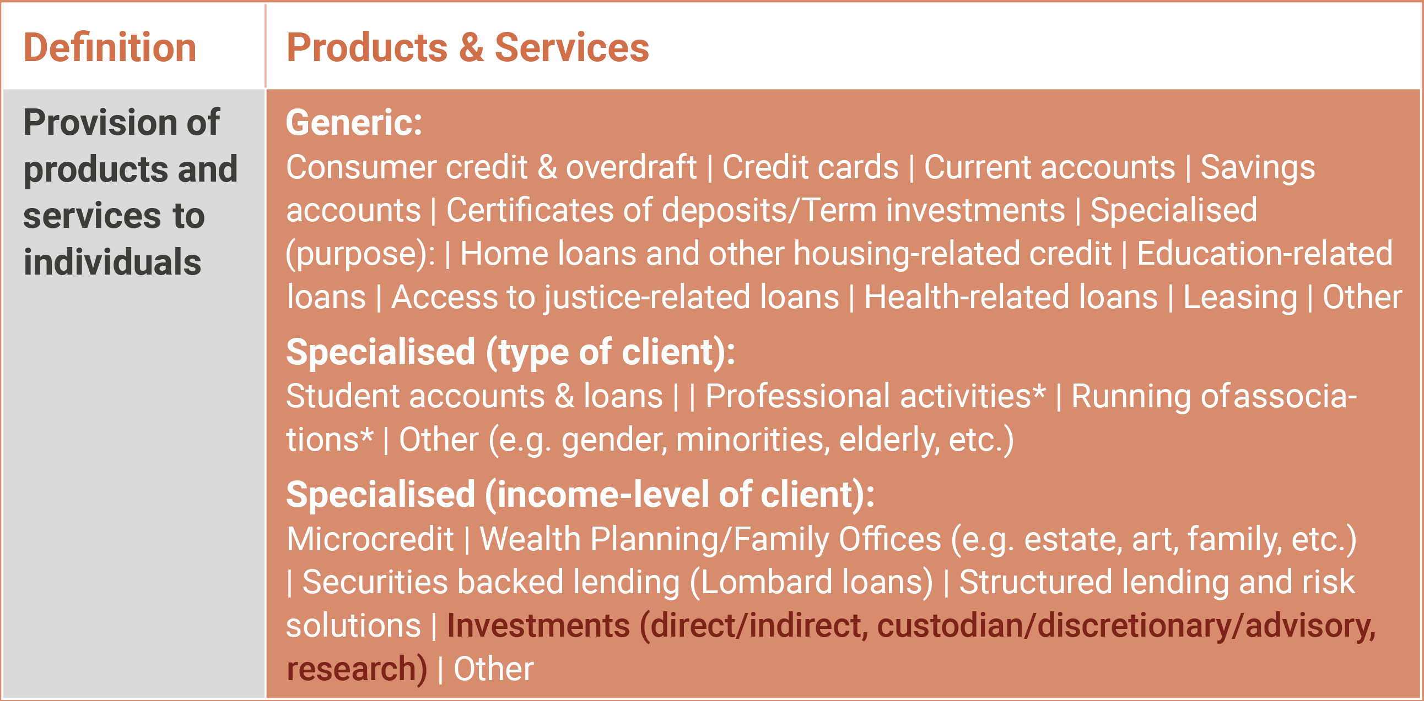

- List of products and services understood to form part of the Institutional Banking (sometimes also called commercial banking):
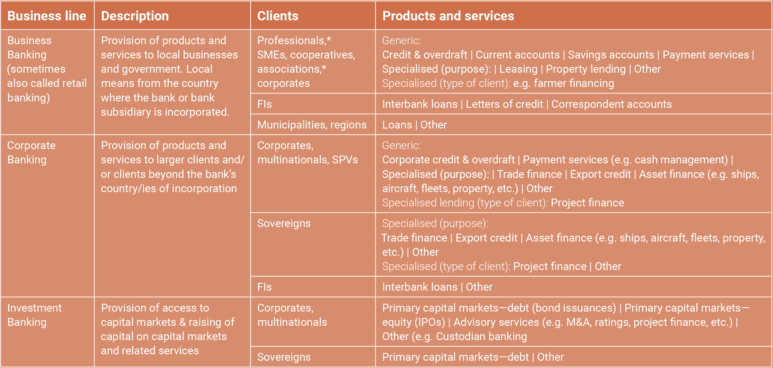

More information on the PRB at: http://www.unepfi.org/responsiblebanking; for NZBA at: https://www.unepfi.org/net-zero-banking.

